A **servo motor** is a type of motor that is used for precise control of angular position. It is typically used in applications where precise positioning and control of rotation are required, such as in robotics, camera positioning, and RC models. Unlike regular motors that rotate continuously, a servo motor can rotate to specific angles, typically from 0° to 180°, depending on the servo.

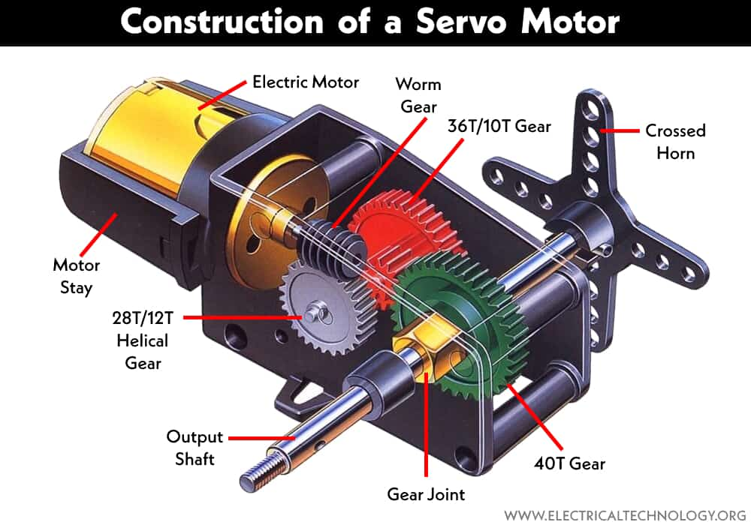

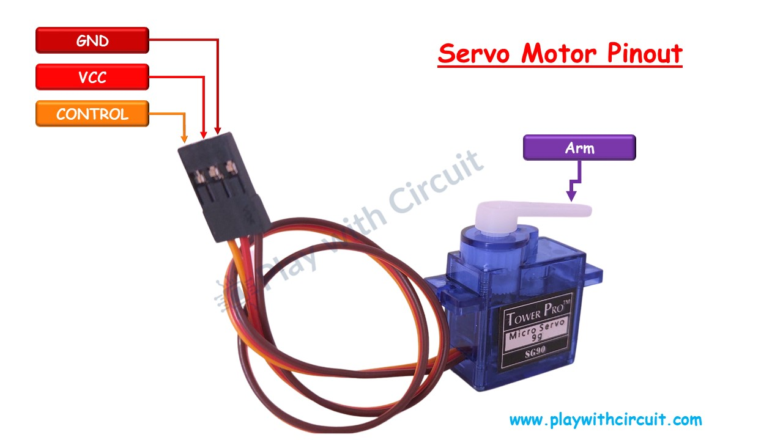

**Key Components of a Servo Motor:**

1. **Motor**: The core motor inside the servo that produces rotational motion.
2. **Gearbox**: A set of gears that translates the rotational motion of the motor into a controlled, precise movement.
3. **Feedback Mechanism**: A potentiometer inside the servo that provides feedback to the controller to ensure the motor reaches the correct position.
4. **Control Circuit**: This circuit controls the motor's rotation based on the input signal it receives.

**How a Servo Motor Works:**

A servo motor works by receiving a **pulse-width modulation (PWM)** signal, which is used to control its position. The servo's internal control circuitry interprets the width of the pulse to determine the desired position of the motor shaft.

* A typical PWM signal for a servo motor consists of a series of pulses with a fixed frequency (often 50 Hz), where the width of the pulse (duration of the "high" state) determines the angle of rotation.
* **1 ms pulse** → 0° rotation
* **1.5 ms pulse** → 90° (neutral) rotation
* **2 ms pulse** → 180° rotation

The servo will adjust its shaft to the position corresponding to the pulse width it receives.

**What Happens in the Circuit when connected with Arduino uno r3:**

* When the Arduino sends PWM signals (via myServo.write()), the servo motor adjusts its position to the corresponding angle (based on the pulse width).
* As the Arduino sends commands, the servo will rotate to the desired angle, making it a great tool for tasks requiring precise movement.

**Key Points:**

* The servo motor's movement is controlled by PWM signals, where the duration of the pulse determines the rotation angle.
* The **Arduino Uno** controls the servo motor using the Servo library and sends the appropriate PWM signals.